**Working with Routes:**

Services allow for network access between pods inside an OpenShift instance, and routes allow for

network access to pods from users and applications outside the OpenShift instance.

A route connects a public-facing IP address and DNS host name to an internal-facing service IP. It

uses the service resource to find the endpoints; that is, the ports exposed by the service.

OpenShift routes are implemented by a cluster-wide router service, which runs as a containerized

application in the OpenShift cluster. OpenShift scales and replicates router pods like any other

OpenShift application

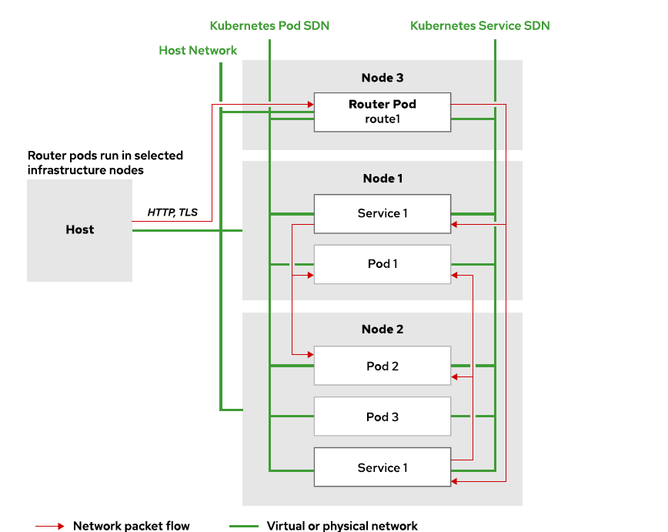

Creating Routes

Use the oc create command to create route resources, just like any other OpenShift resource.The oc new-app command does not create a route resource when building a pod from container images, Containerfiles, or application source code.

[lab-user@bastion ~]$ oc get pods

[lab-user@bastion ~]$ oc get svc

[lab-user@bastion ~]$ oc expose service <servicename>

By default, routes created by oc expose generate DNS names of the form:

**S2i.devloper.apps.ocp4.example.com**

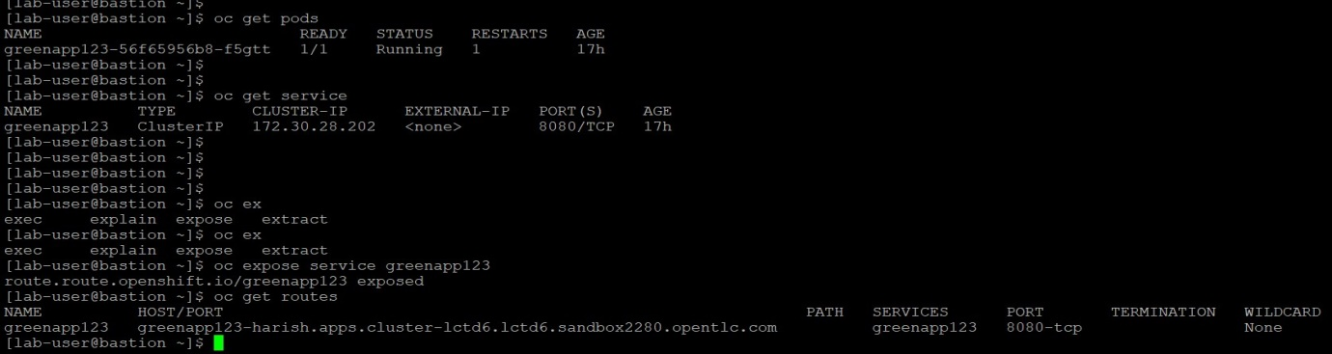

Default Routing Service

[root@workstation~]# oc get pod –all-namespaces | grep router

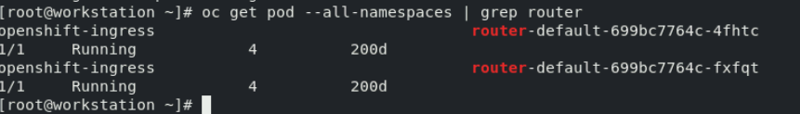

Describing the route

[root@workstation~] # oc describe route <route name>

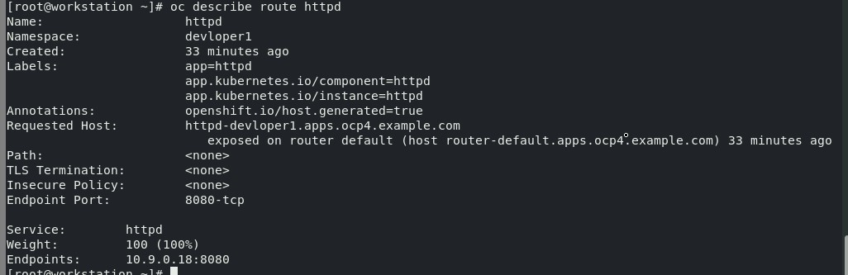

How to access the page by using the route url

[root@workstation ~]# curl <route url>

